Focussed Search Pattern Two

* **a name for the pattern: Multiple-criteria FilteredSearch**
* **a wireframe picture**

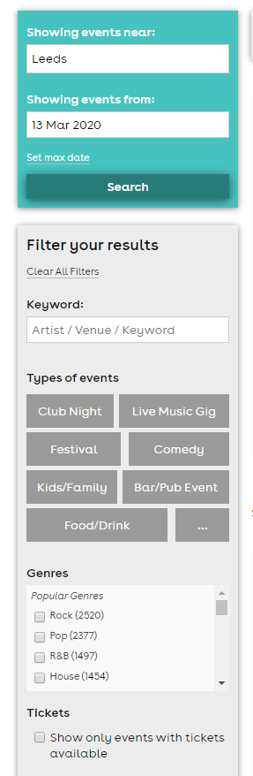

* **use when** (describes when the pattern should be applied)

1. Use when the search results for a query are very numerous and reviewing them would be very time consuming.

2.Use when user wants to limit the number of results, get specific information

3. When the search results can be filtered by fixed criteria

* **how** (describes how the pattern may be applied)

The pattern may be applied to filter search results by applying multiple filter-criteria. The application will present everything available and encourage user to progressively what they do not need by applying one or more filters. With immediate feedback, this pattern helps simplify the search experience. In the browser tab of studEvents application I am going to present the user a list of filter categories, and let the user filter these by inserting input in text boxes, choosing options in dropdown boxes or even through checkboxes or radiobuttons. Whenever the user makes a change to any of the input fields, the results are automatically updated.

* **a discussion of** how you have applied this pattern in your own information seeking.

I use this pattern when I am not too sure of what I am looking for. By applying filters I can limit the search results and save a lot of time. For example, when choosing a car, I can apply filters like: price range, engine power, number of doors, year of production, model etc. In this case, I am limiting the results in the way I want and it makes the search process much easier and time consuming.